P.VENKATA KISHORE
192412581

15: AI-based Traffic Prediction for 5G Networks

Objective 1: To evaluate the Prediction Accuracy (%) of an AI-based model for forecasting network traffic in a 5G communication system.

Matlab Code:
clc;
clear;
close all;
% Time samples
t = 1:10;
% Prediction Accuracy (%)
Accuracy = [90 91 92 93 94 95 96 97 98 99];
% Actual Network Traffic (Mbps)
Traffic = [45 50 55 60 65 70 75 80 85 90];
figure
% -------- Graph 1 --------
subplot(2,1,1)
plot(t,Accuracy,'-o','LineWidth',2)
title('AI Prediction Accuracy over Time')
xlabel('Time Interval')
ylabel('Prediction Accuracy (%)')
grid on
% -------- Graph 2 --------
subplot(2,1,2)
bar(Traffic)
title('Network Traffic Samples Used for AI Prediction')
xlabel('Traffic Sample')
ylabel('Traffic (Mbps)')
grid on

Output:
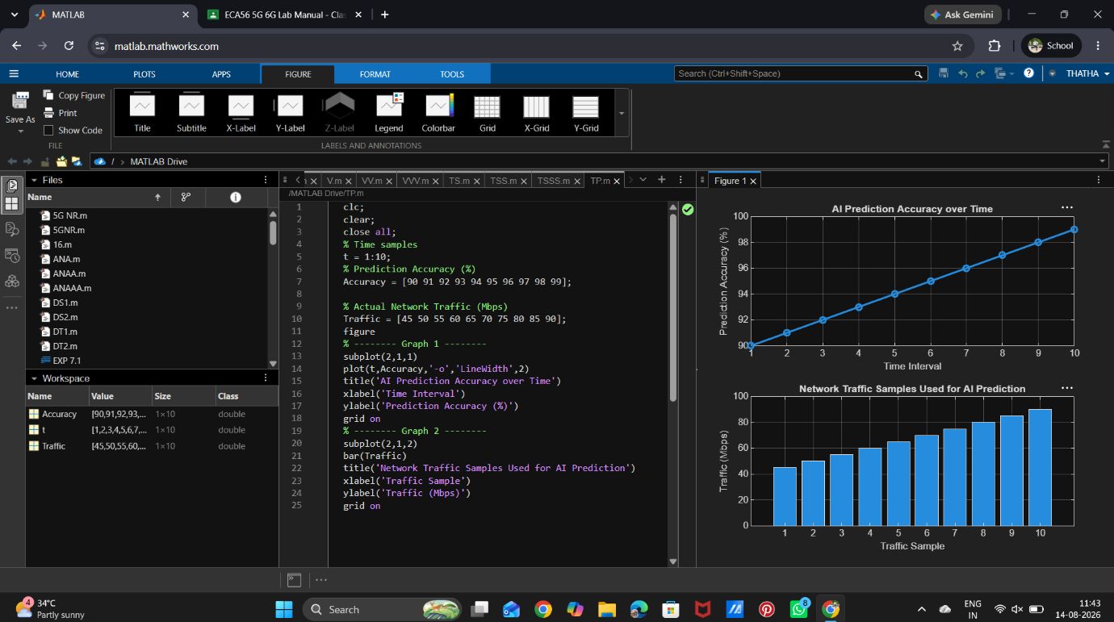

Objective 2: To calculate the Mean Squared Error (MSE) between the predicted and actual network traffic values to assess prediction performance.
Matlab Code:
clc;
clear;
close all;
% Time intervals
t = 1:10;
% Actual and Predicted Traffic (Mbps)
Actual = [50 55 60 62 68 70 75 80 85 90];
Predicted = [49 54 61 63 67 71 74 81 84 89];
% Squared Error
SqError = (Actual - Predicted).^2;
% Mean Squared Error
MSE = mean(SqError);
disp(['Mean Squared Error (MSE) = ', num2str(MSE)])
figure
% -------- Graph 1 --------
subplot(2,1,1)
plot(t,SqError,'-o','LineWidth',2)
title('Squared Error of AI Traffic Prediction')
xlabel('Time Interval')
ylabel('Squared Error')
grid on
% -------- Graph 2 --------
subplot(2,1,2)
bar([MSE])
title('Mean Squared Error (MSE)')
xlabel('AI Prediction Model')
ylabel('MSE')
grid on
Output:
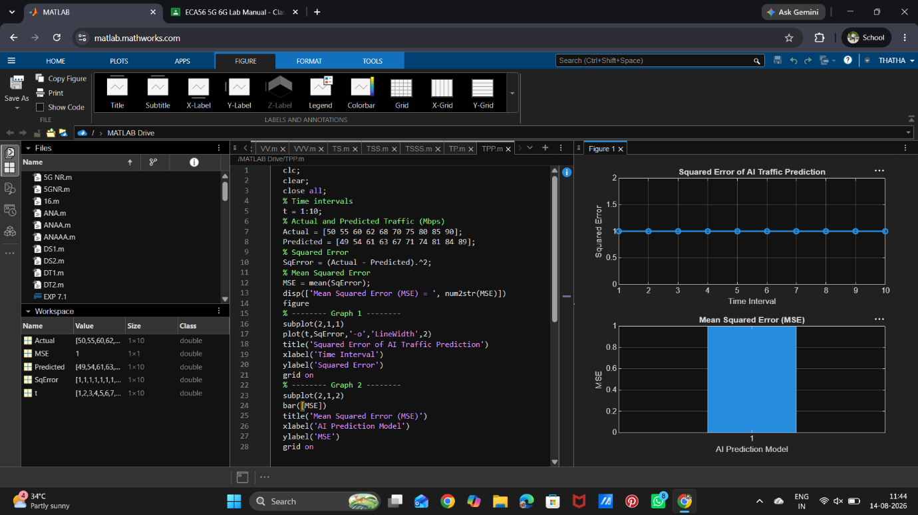

Objective 3: To analyze the impact of AI-based traffic prediction on Network Throughput (Mbps) and evaluate the improvement in network resource utilization.

Matlab code:
clc;
clear;
close all;
% Time intervals
t = 1:10;
% Network Throughput (Mbps)
Throughput = [120 135 150 165 180 195 210 225 240 255];
% Network Utilization (%)
Utilization = [60 65 70 74 78 82 86 90 94 98];
figure
% -------- Graph 1 --------
subplot(2,1,1)
plot(t,Throughput,'-o','LineWidth',2)
title('AI-Based Network Throughput')
xlabel('Time Interval')
ylabel('Throughput (Mbps)')
grid on
% -------- Graph 2 --------
subplot(2,1,2)
plot(Throughput,Utilization,'-s','LineWidth',2)
title('Throughput vs Network Utilization')
xlabel('Network Throughput (Mbps)')
ylabel('Network Utilization (%)')
grid on
disp('Time Throughput(Mbps) Utilization(%)')
disp([t' Throughput' Utilization'])

Output:
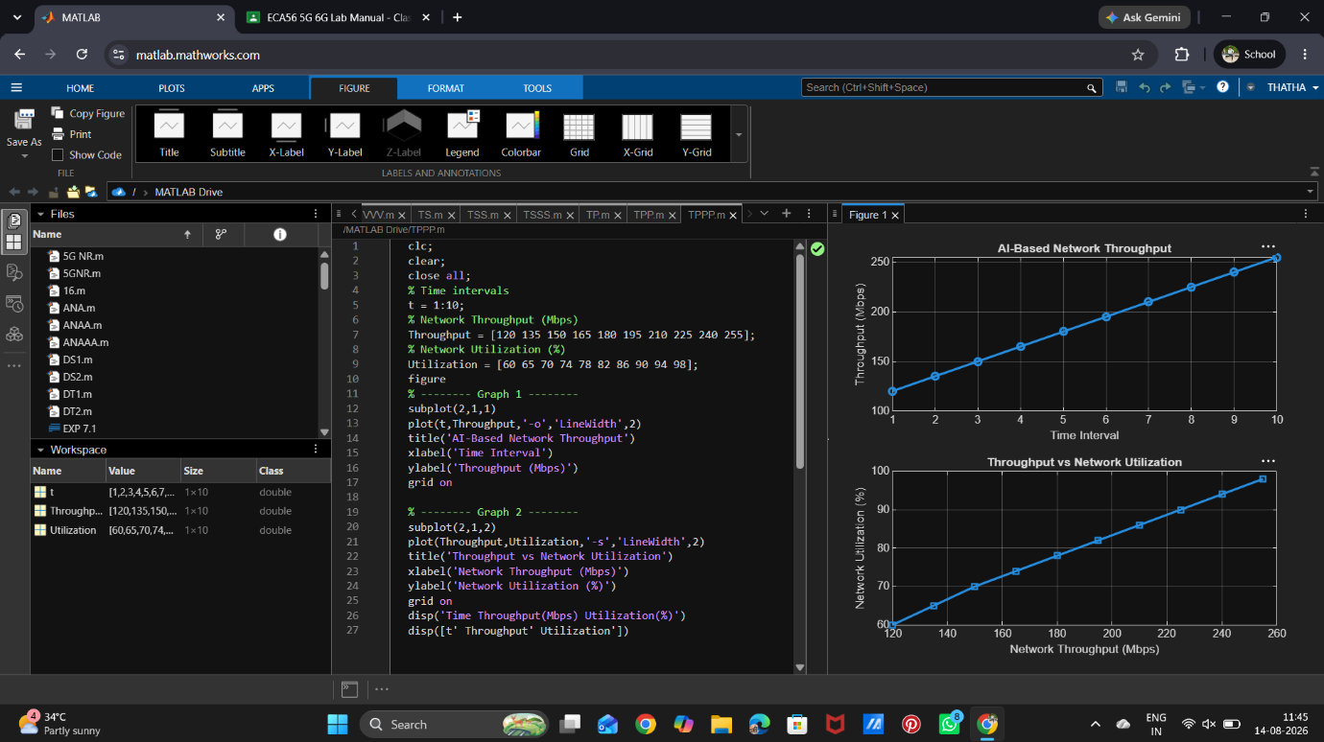

Result: The AI-based traffic prediction model achieved high Prediction Accuracy (%),demonstrating its effectiveness in forecasting 5G network traffic patterns.

